Project Proposal

Find Your Game  
(provisional name)

Marta Pacheco Merino, 21179999, x21179999@student.ncirl.ie

Higher Diploma in Science in Computing

Web Development

06/10/2022

# Objectives

Despite being an avid videogame fan, I have always found it difficult to discover games that really grab me. No matter how much our friends advise us, the feeling between the player and the game has to be generated in a way that, in a way, is comparable to that of love for other people. So I came up with the idea of creating a "Tinder" for the videogame, with the intention of finding the best match between the player and the game.

It’s clear that this application is not made to suffice a need and it’s not going to change the world, but I think that it will be worth it if just helps a few people to find a good entertainment they feel identified with. It’s very important to be able to disconnect from reality nowadays and that’s part of our job when we create user friendly websites and applications, so I’ll try to achieve that.

# Background

I came up with this idea thinking that, being the world of videogames so tied to new technologies, it would not be complicated to find databases based on keywords, and it would be possible to generate batteries of questions for the user, associating them with keywords that would then be matched with those in the database to give rise to a list of games from which the user could give likes to those that interest him or her.

For example :

« What would you do if you are 100m away from your bus stop and you see your bus with the doors open ?

1. Run to it, I’m late as usual !
2. Run to it, I’m perfectly on time but my mind would be in peace getting the bus !
3. Keep walking calmly, I don’t really care being late.
4. I stop in the coffee shop and get a drink, I got out an hour earlier !

Each answer could get associated some keywords (adrenaline, chill out, responsibility, tasks, etc), and get matched with keywords stored in a database for each game. Therefore, if someone usually gets answers related to adrenaline, we could recommend them games like shooters, battle royale, etc. If the user usually gets laid back answers, we could recommend them farming games, puzzles, etc.

As an extra feature, it would be ideal to be able to recommend related games based on those that have already been liked, but the truth is that I don't know how to do it at the moment, so I don't know if it's too ambitious as an idea, but I would actually love to use a feature like that for myself, so I’ll fight to achieve it.

This application would be suitable for all kinds of people. It could seem that it’s just for gamers, but I actually think that, for example, elder people could give it a try and maybe get a recommendation about some mental training games. At the end, if I find a database that includes them, this would also include phone games, not just consoles.

# Technical Approach

Given the immensity of the number of videogames in the market, we would 100% need an external database to retrieve information about the games, so this would be the first requirement.

Even though we have studied databases and how to implement them in front-end through PhP and React, I will have to retrieve information about how to specifically go through this assignment, as the information we have gotten is very general and now it’s time for us to give a huge and specific approach to a practical case like ours.

# Special resources required

In order to test the application, we will need computers, tablets and mobile devices (or their simulators in a computer).

# Project Plan

Microsoft Project didn’t allow me to create a project, so I used <https://onlinegantt.com>

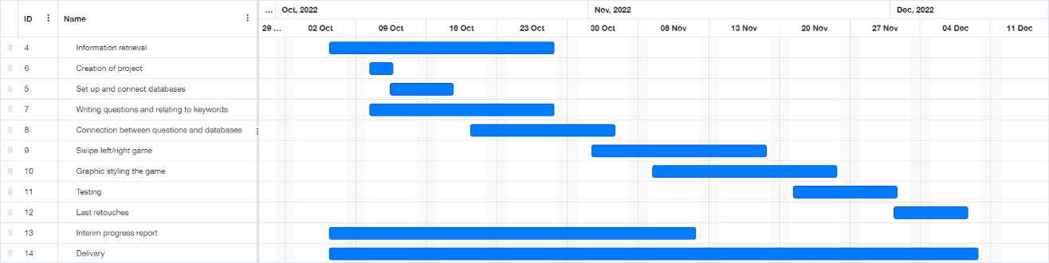

# Technical Details

I have very clear the fact that I’d like to improve and get solid knowledges of JavaScript, as I’ve been working in front-end for a while and have just been working with HTML, CSS and JQuery, and need to set the basis of the language I use to interact with the site, instead of basically copying and pasting code from Stack Overflow.

Therefore, and being React the “easy” option, I would like to use raw JavaScript to develop the project (I don’t really think it’s realistic, so I still have to decide about it). For the retrieval of information, it’s actually depending on the most reliable source I can find. I would prefer to use external APIs directly on JS or React as the plan B, and use PhP with the only purpose of optimising the front-end experience (to avoid repeating content).

Of course, a strong front end is a must in any kind of application, but it’s especially important for me as a graphic designer myself, so I’ll give it a strong part of my work (no matter if it’s necessary or not for my mark).

# Evaluation

Well, evaluating the application won’t be a big issue, given the fact that all my social circle is composed of avid gamers, being half of them software developers. However, I’ll perform technical tests optimised for the chosen technology, and try to break the application myself before delivering to other users. After a first trial of my closest circle, I’d like to take some strangers testing it to have objective opinions, not just about the applications performance, but also about its accuracy and the quality of results that will give. That’s only doable with human opinions.



_____________________

Marta Pacheco Merino, 06/10/2022